**Computer-Aided Tools in Engineering Assignment Week 4**

**Name: Nguyen Xuan Binh   
Student ID: 887799**

**Home Exercise 1.1**

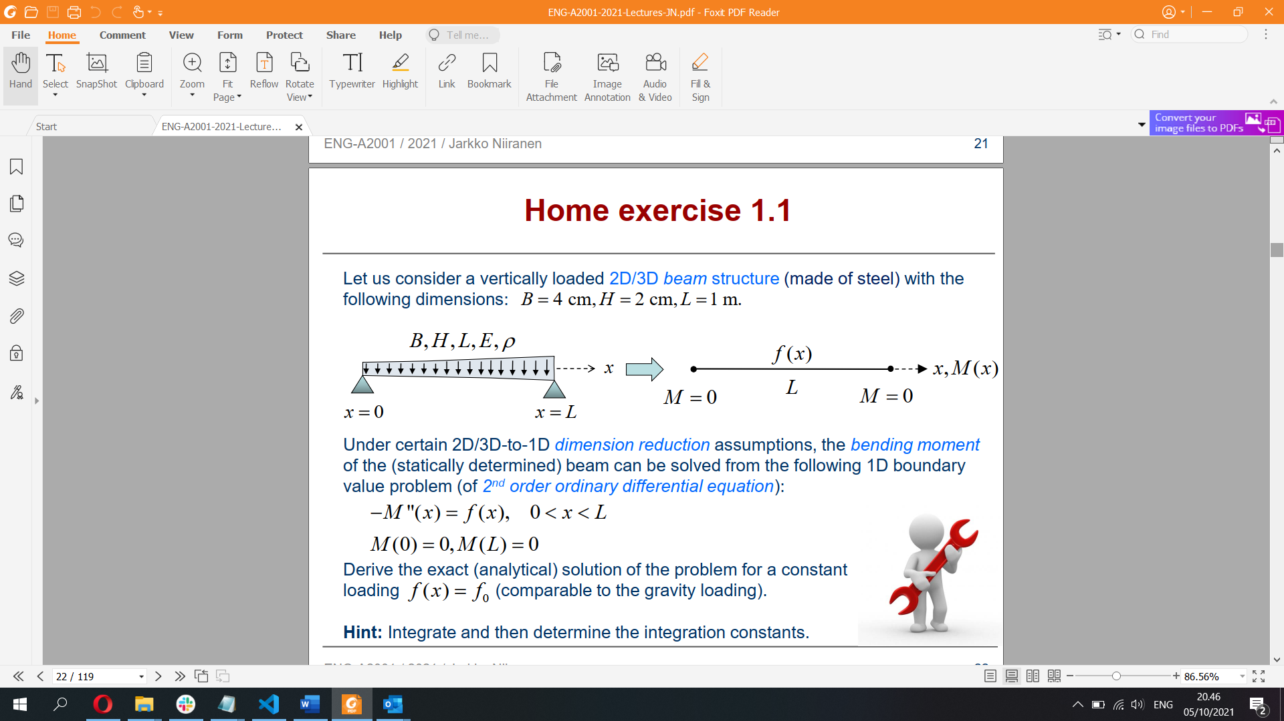

We have:



=> Second derivative: 

=> Applying integral, the first derivative is

=> Applying integral, the original function is 

Boundary conditions:

 

Final answer: Exact solution of the problem  


**Computer Exercise 1.1**

Graph of exact solution M = M(x) with loading f(x) = f0, 10 points for curve discretization

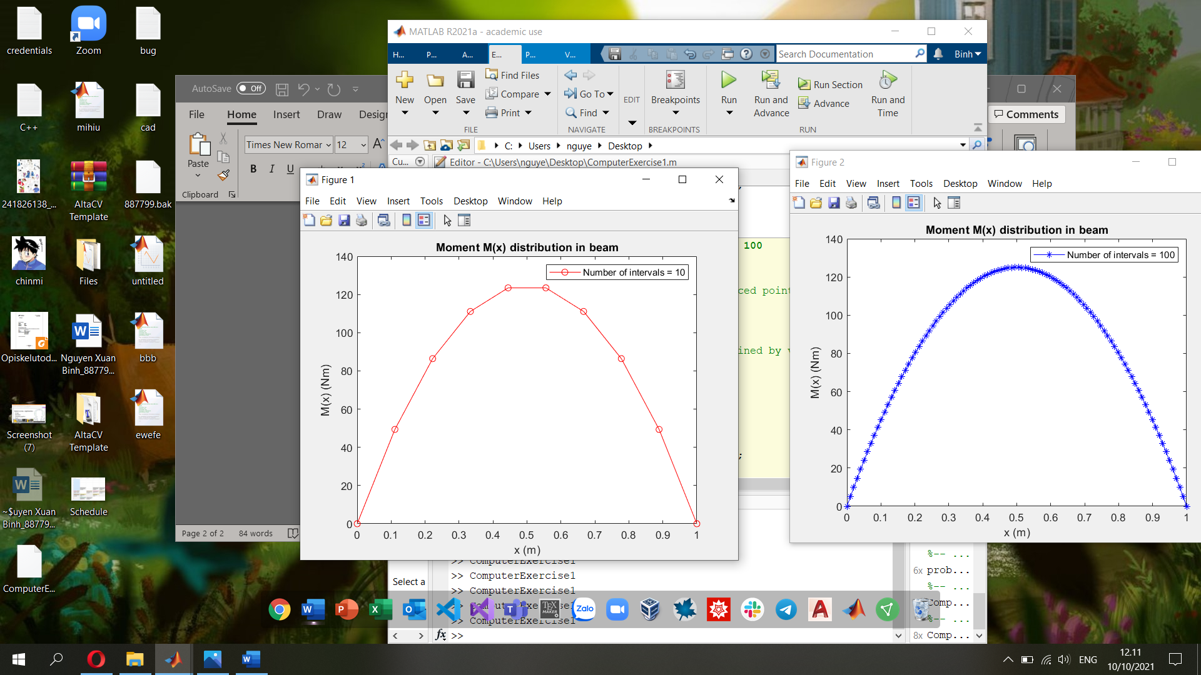

Graph of exact solution M = M(x) with loading f(x) = f0, 100 points for curve discretization

The MATLAB code for this exercise:

%% Parameters

f0 = 1000; % Distributed load value, unit (N/m)

L = 1; % Length of the beam, unit (m)

%% Specifying the interval number for n = 10

n = 10;

% Creating a vector which has equally spaced points between 0 and L

% Number of intervals = n

x = linspace(0,L,n);

% Calculating moment values in points defined by vector (array) x

Mx = (0.5*f0*L^2)*(-((x/L).^2) + (x/L));

% Plotting the graph

figure(1);

plot(x, Mx, 'r-o');

xlabel('x (m)');

ylabel('M(x) (Nm)');

title('Moment M(x) distribution in beam');

legend('Number of intervals = 10');

%% Specifying the interval number for n = 100

n = 100;

% Creating a vector which has equally spaced points between 0 and L

% Number of intervals = n

x = linspace(0,L,n);

% Calculating moment values in points defined by vector (array) x

Mx = (0.5*f0*L^2)*(-((x/L).^2) + (x/L));

% Plotting the graph

figure(2);

plot(x, Mx, 'b-*')

xlabel('x (m)')

ylabel('M(x) (Nm)');

title('Moment M(x) distribution in beam');

legend('Number of intervals = 100');

**Computer Exercise 3.1 – MATLAB PDE Modeler**

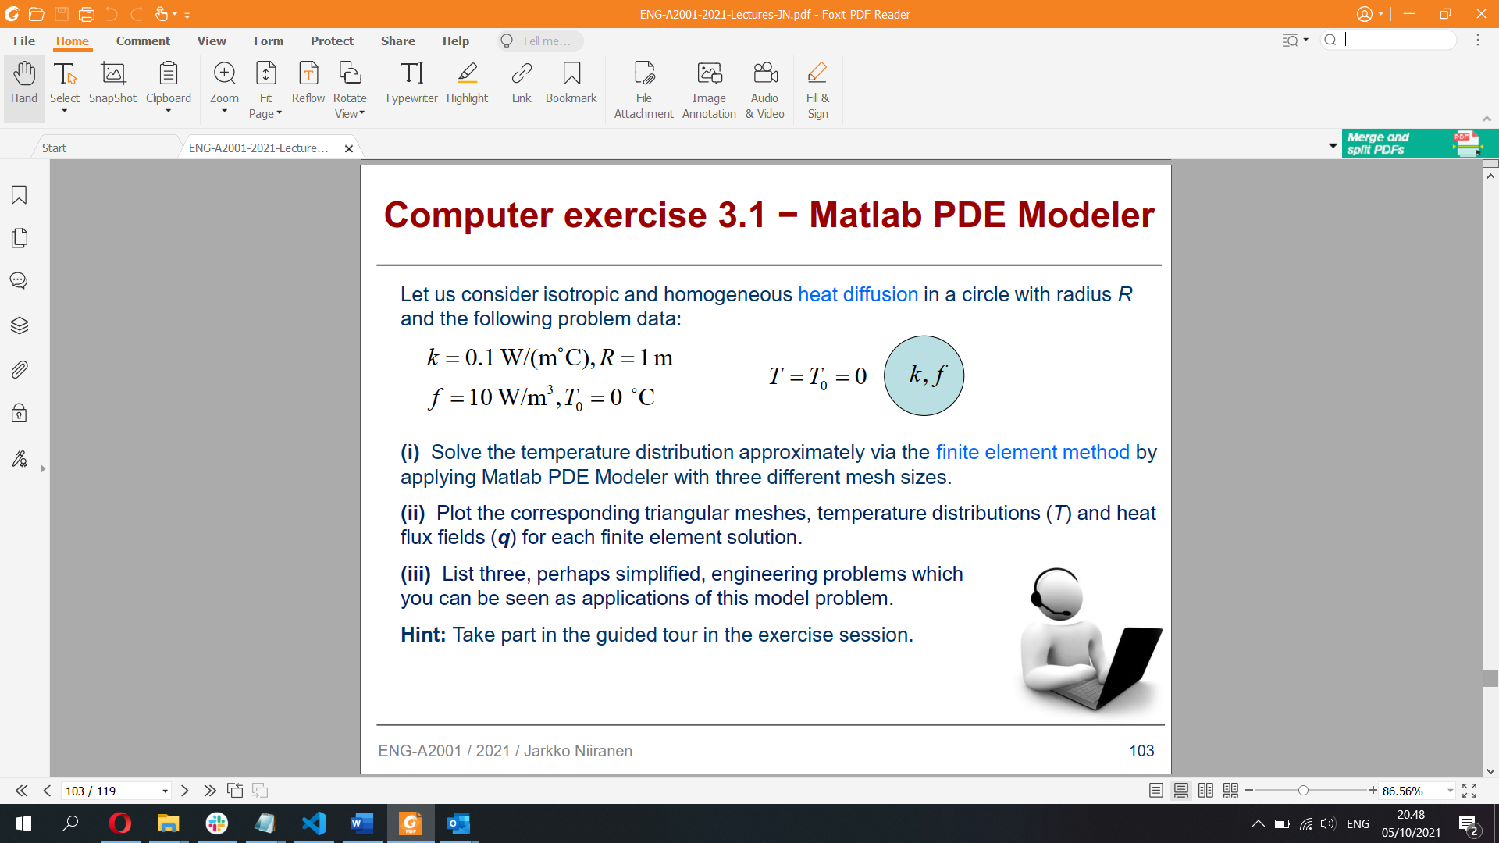

i) Solving temperature distribution via FEM by PDE Modeler

Maximum edge size = 1

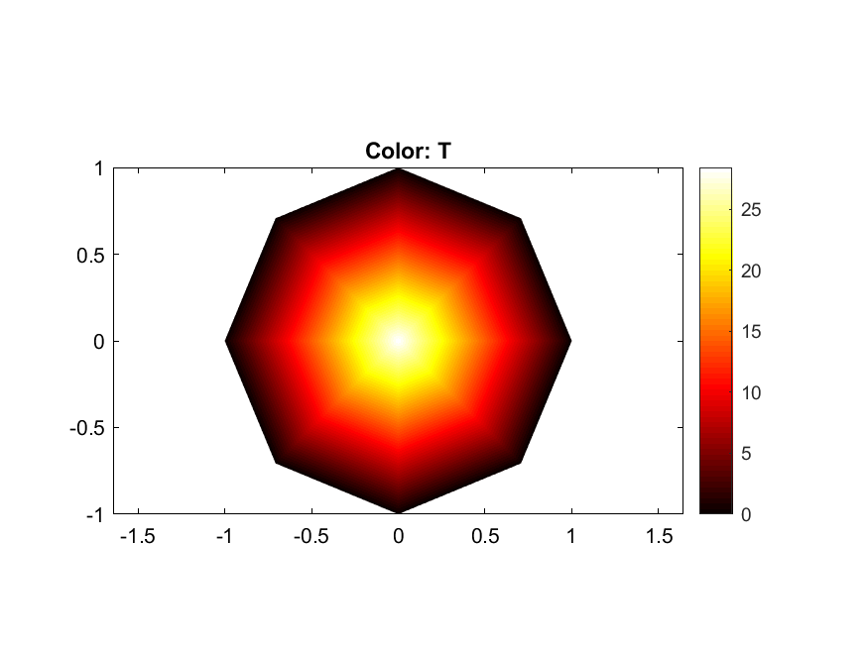  
Maximum edge size = 0.5

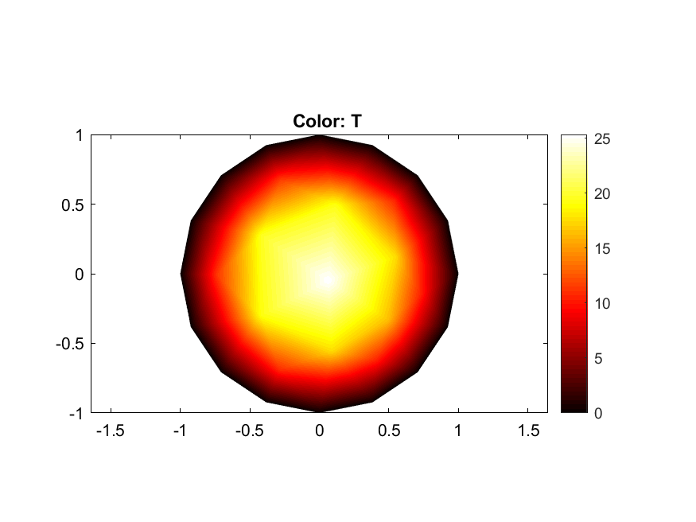

Maximum edge size = 0.2

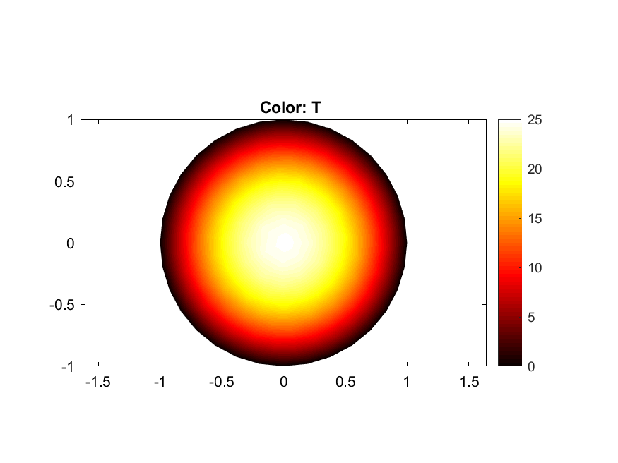

ii) Plot triangular meshes, temperature distributions (T) and heat flux fields (q) (Proportional)

Maximum edge size = 1

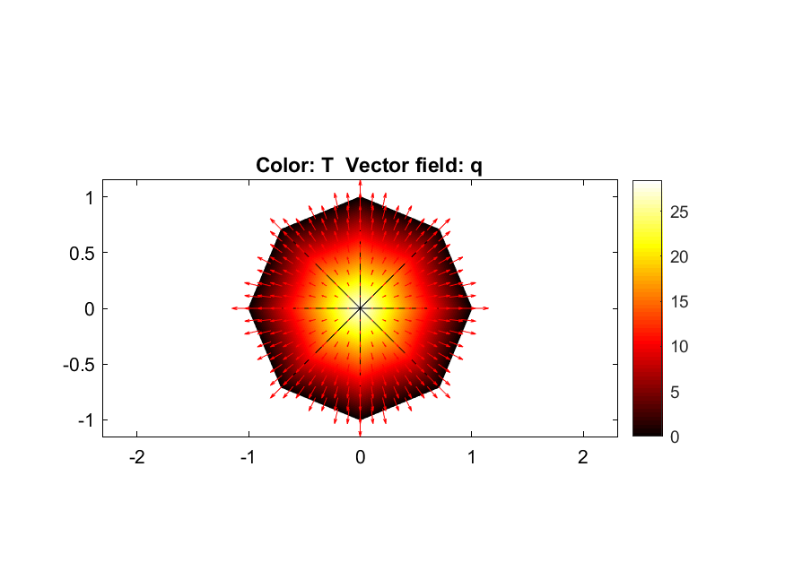

Maximum edge size = 0.5

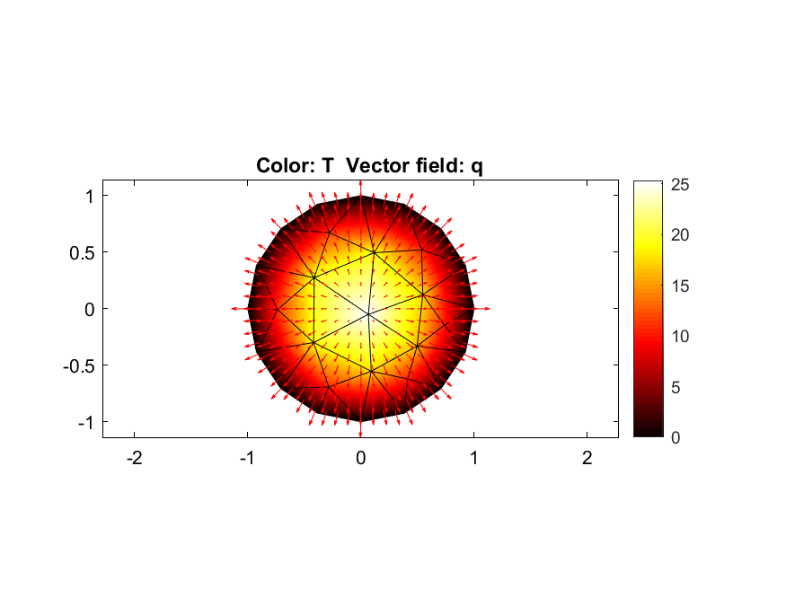

Maximum edge size = 0.2

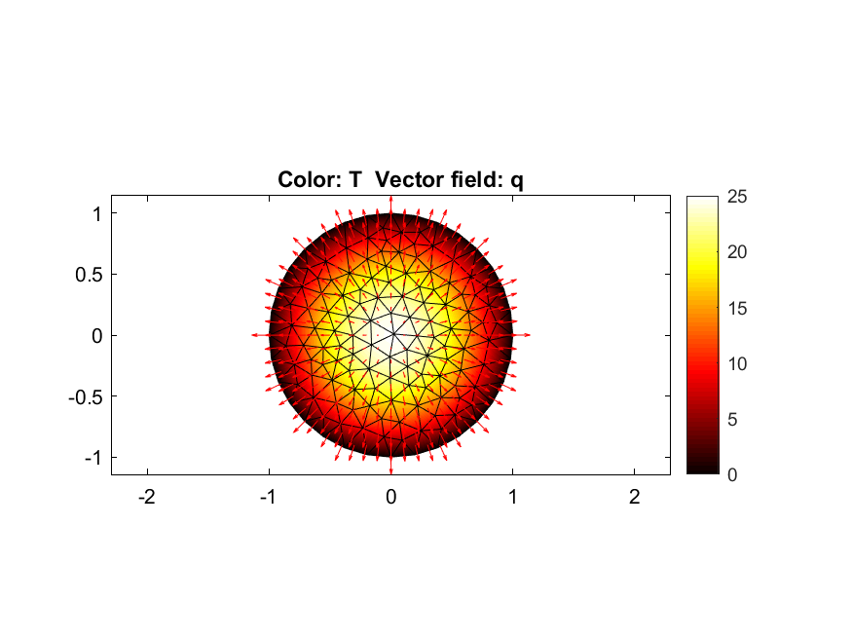

iii) Three engineering applications of the model problem:

1) Study the heat distribution on the electric stove, where heat will transfer from a hot burner on the stove into the pan.

2) Study the how temperature is distributed emanated from radiators, which are [heat exchangers](https://en.wikipedia.org/wiki/Heat_exchanger) used for cooling [internal combustion engines](https://en.wikipedia.org/wiki/Internal_combustion_engine) mainly in [automobiles](https://en.wikipedia.org/wiki/Radiator_(engine_cooling)#Automobiles_and_motorcycles) and aircrafts

3) How heat networks in an urban area distribute the heat via insulated pipes underground

**Computer Exercise 3.2 – MATLAB PDE Modeler**

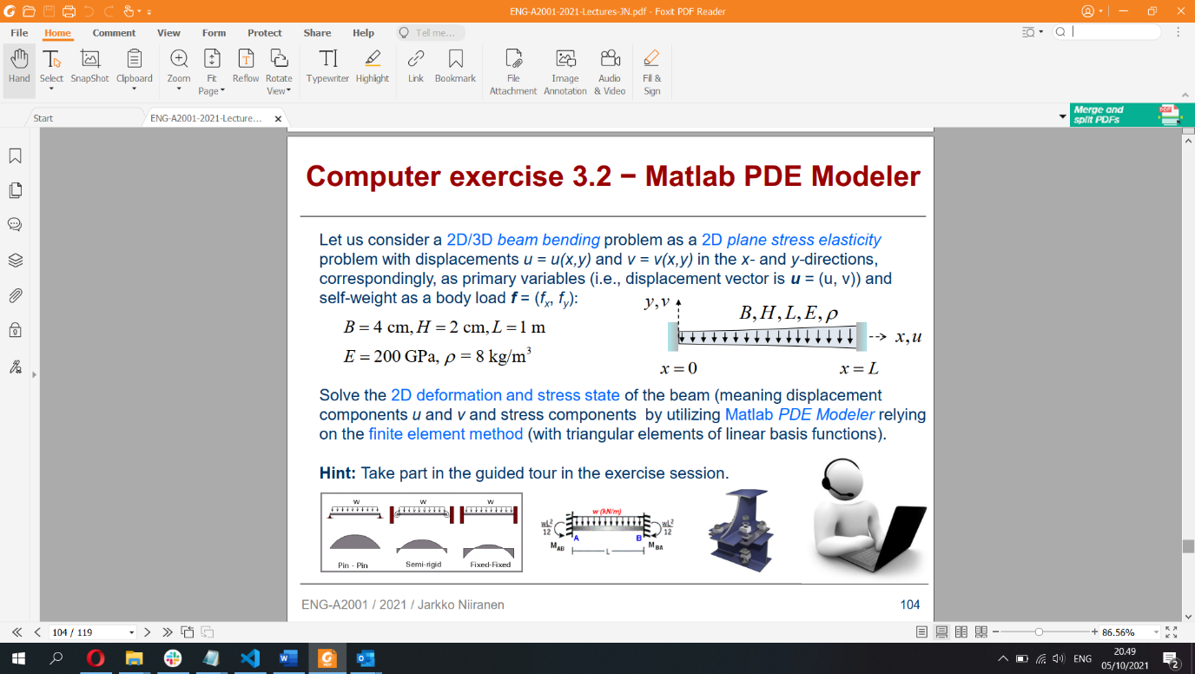

Mesh refined 3 times:  
x-displacement

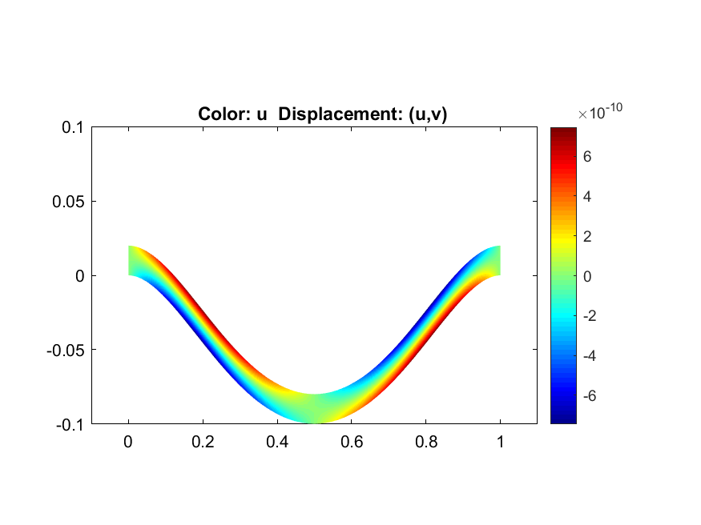

y-displacement

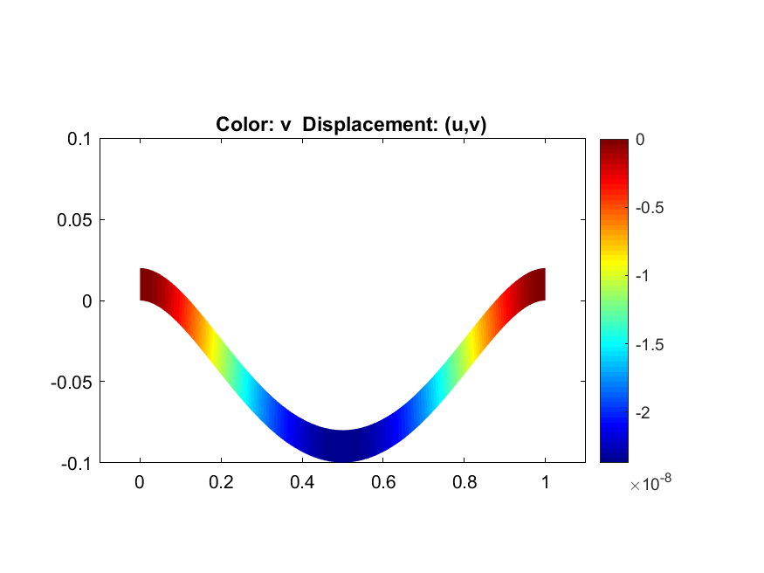

x-stress

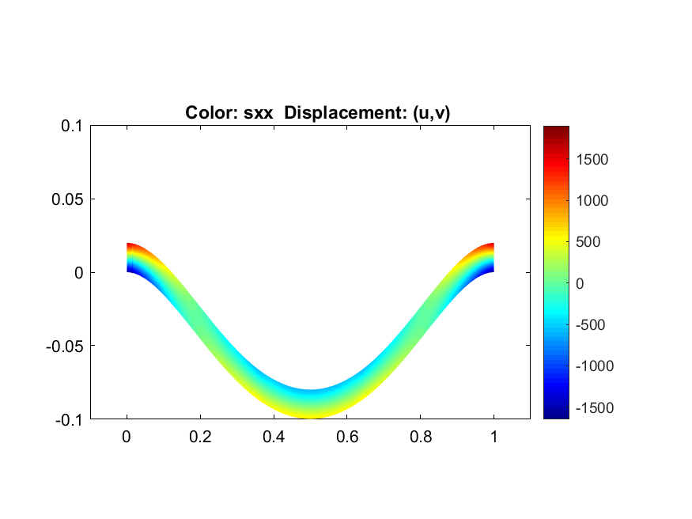

y-stress

